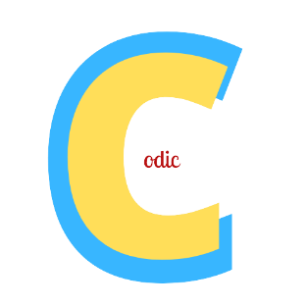**Codic**

Codic combines music and coding and lets you do the same without opening multiple windows. It splits the screen with the music player on one side and the editor on the other. You can easily resize the panels and also hide them as convenient. Codic is the first of its kind editor where you can code while simultaneously listening to music on the same window! It’s a great tool for multitaskers.

The songs are fetched from an API and displayed to you according to your search. Codic plays the next song automatically once the first finishes.

This way you can continuously keep listening songs and code simultaneously without distractions.

Sumanyu Aggarwal

Class 9

Independent